## Exercise SQL01-EX-01:

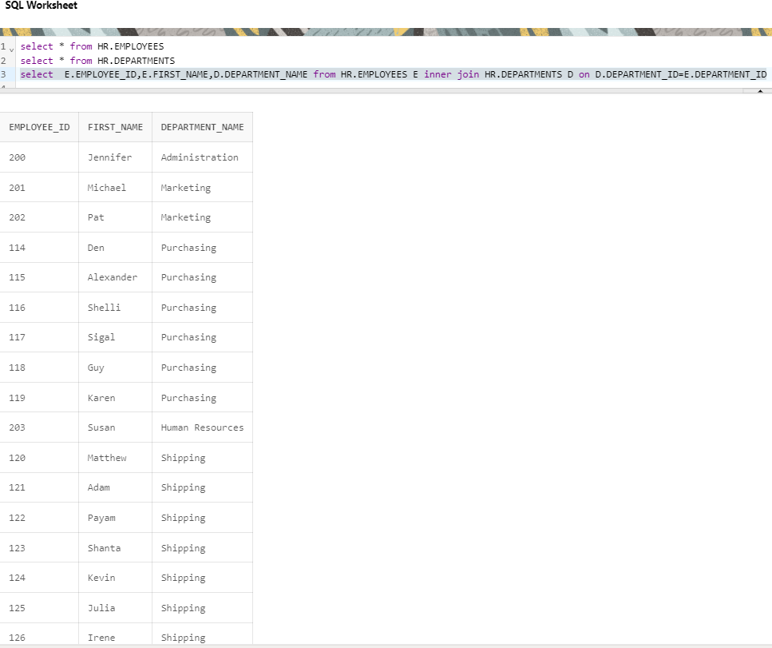

## Exercise SQL01-EX-02:

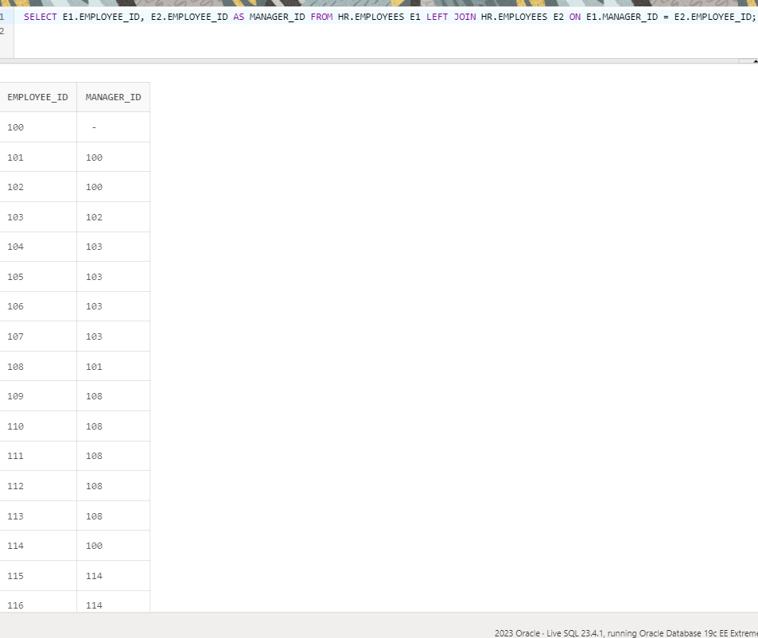

## Exercise SQL01-EX-03:

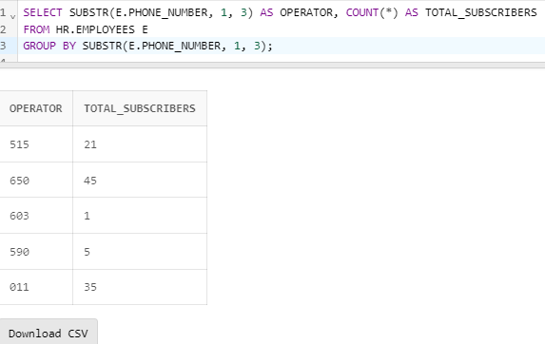

## Exercise SQL01-EX-04:

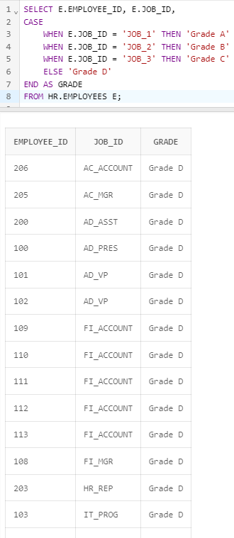

## Exercise SQL01-EX-05:

